Software Engineering, Lab-1

How to Create your profile on GitHub:

Step-1:
Before creating a profile, ensure that you a created a github account.
If not so, then navigate to ‘GitHub’ website and click on <Sign up>.
Enter you personal email-id, password and create a password for your GitHub account.
Then, you will be asked to verify your account, you can do that by entering the code sent to your registered email for GitHub.

Finally after verification of your account, you will be navigated to your gitam dashboard.
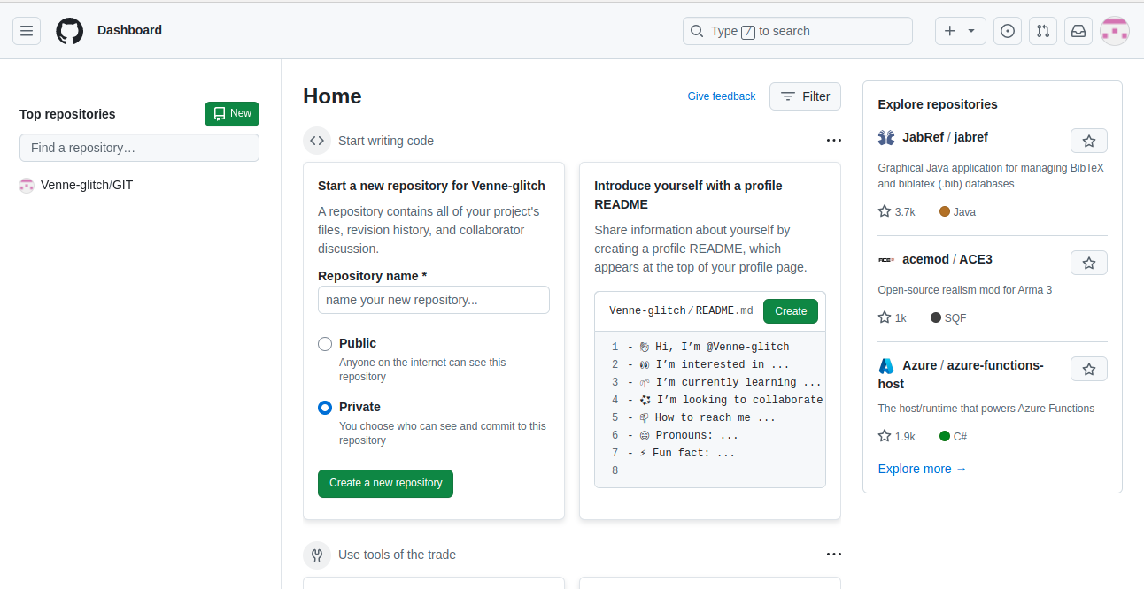
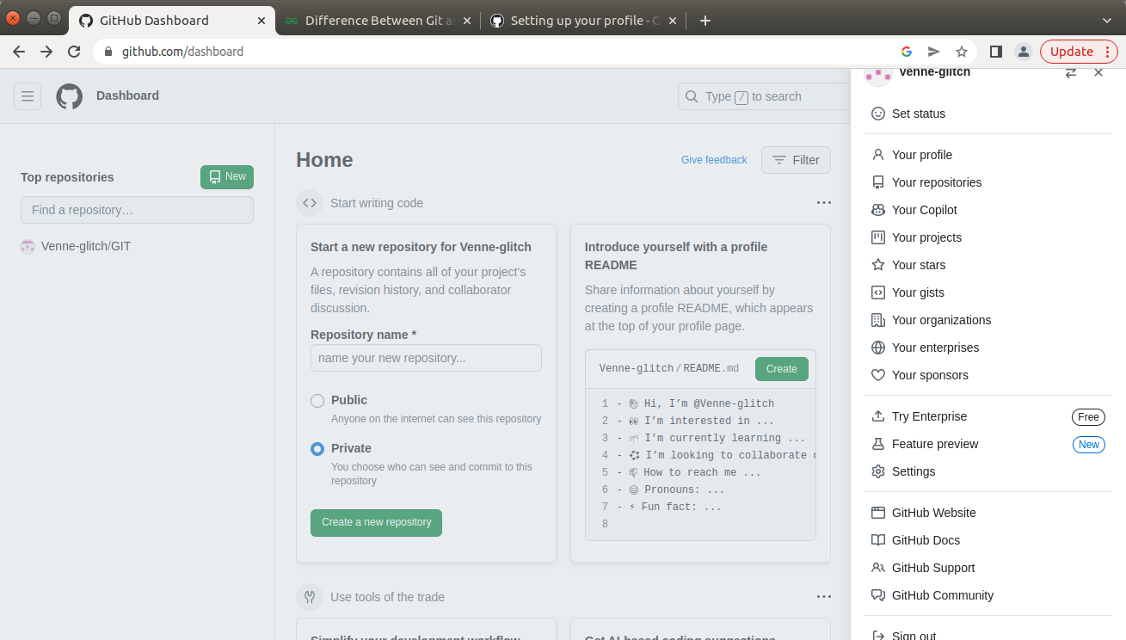
In the drop-down menu, click on <Setting> and it will take you to your section to edit your profile:
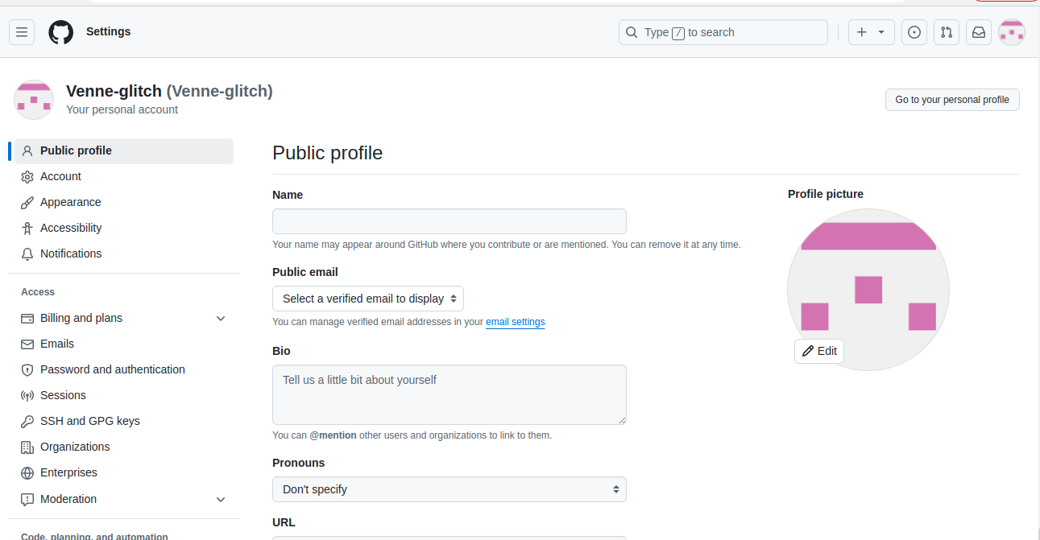
Step-3:
Now lets add a picture to your profile pic. This can be done by clicking on <Edit> and <Upload a photo>.
If you can also enter your bio, there is a <Bio> sub-heading and your can enter data about you and your interestes.
You can also create a public-name, that will appear in GitHub when you contriute to a project.
You can also enter your pronouns (optional) and upload your social media links. Also you can enter your organization name,

And thats it, your GitHub profile is ready. You can now start creating new repositories and upload code anf files in GitHub.

